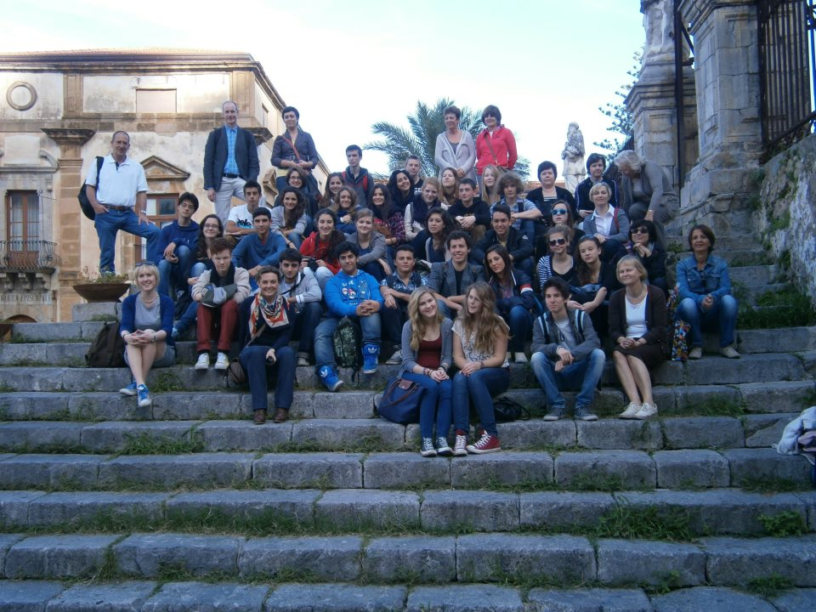
Hi! My name is Arianna and I’m from Palermo.
I had an experience with Comenius last November and it was amazing!
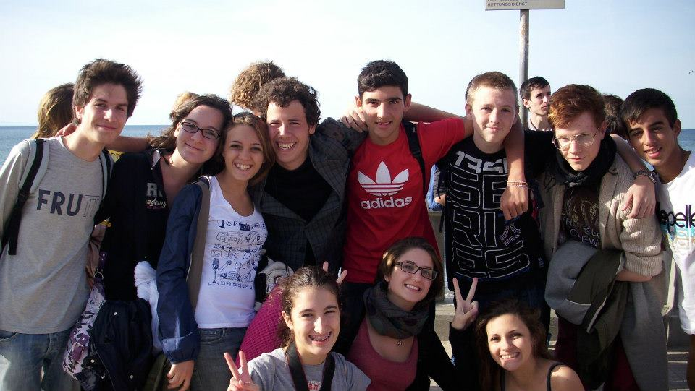

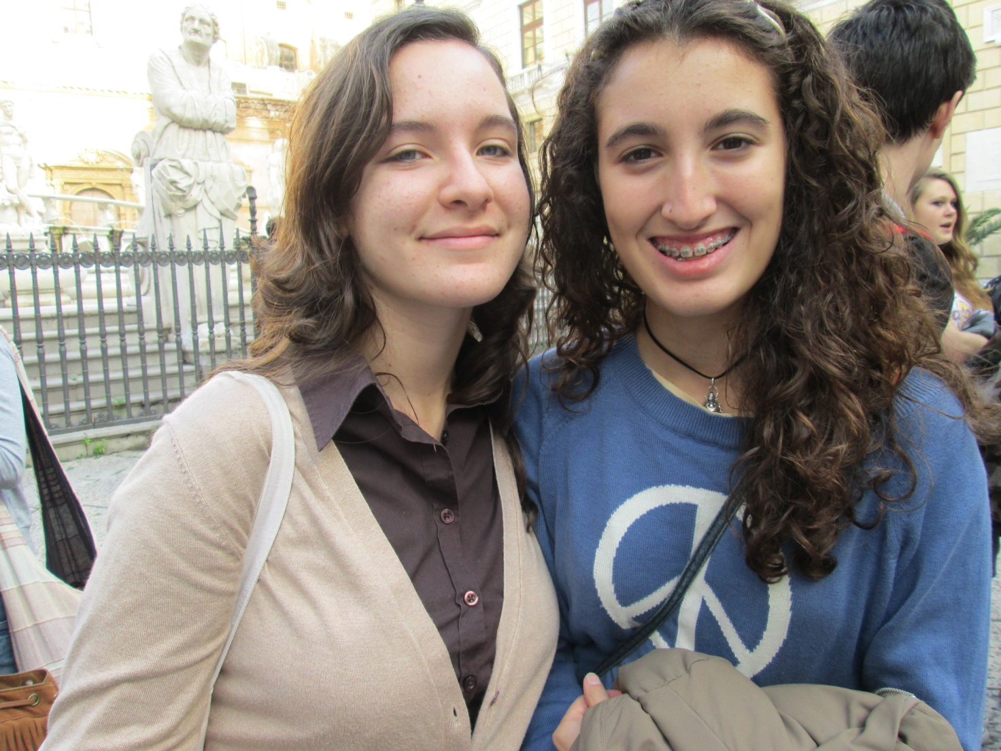

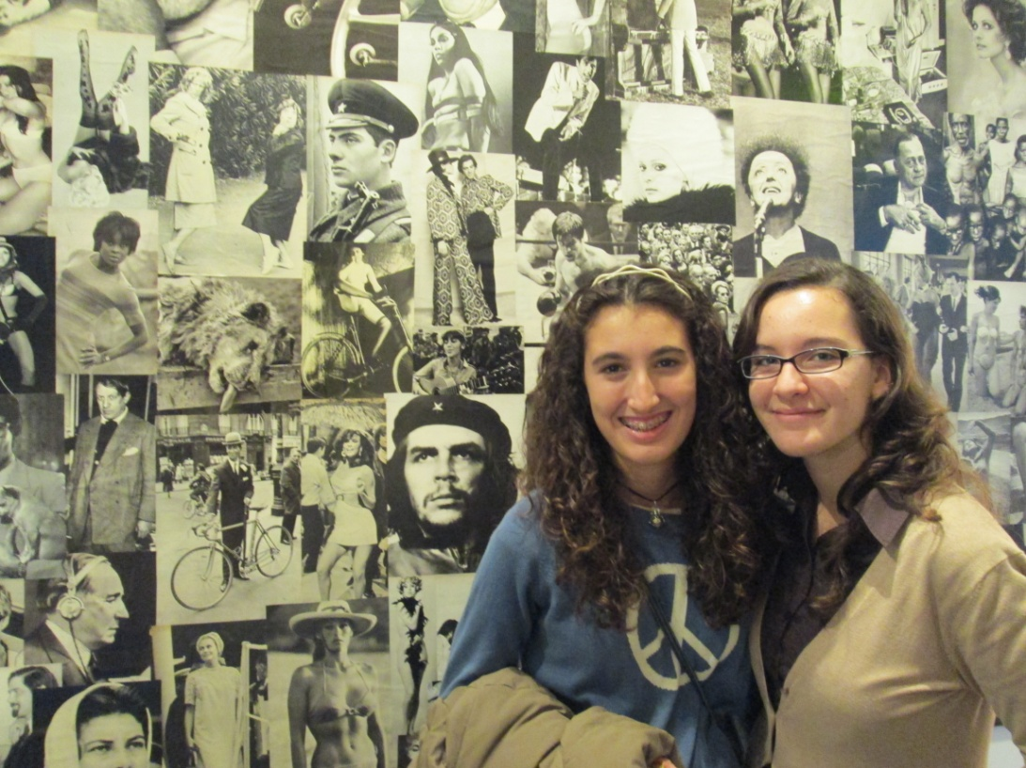
I was very happy because only 18 people from my school could participate, so when I managed to join the group of Comenius I was very excited! I had a twin very pretty, Livia, and we had a lot of things in common. I will meet her again soon, I just can’t wait!
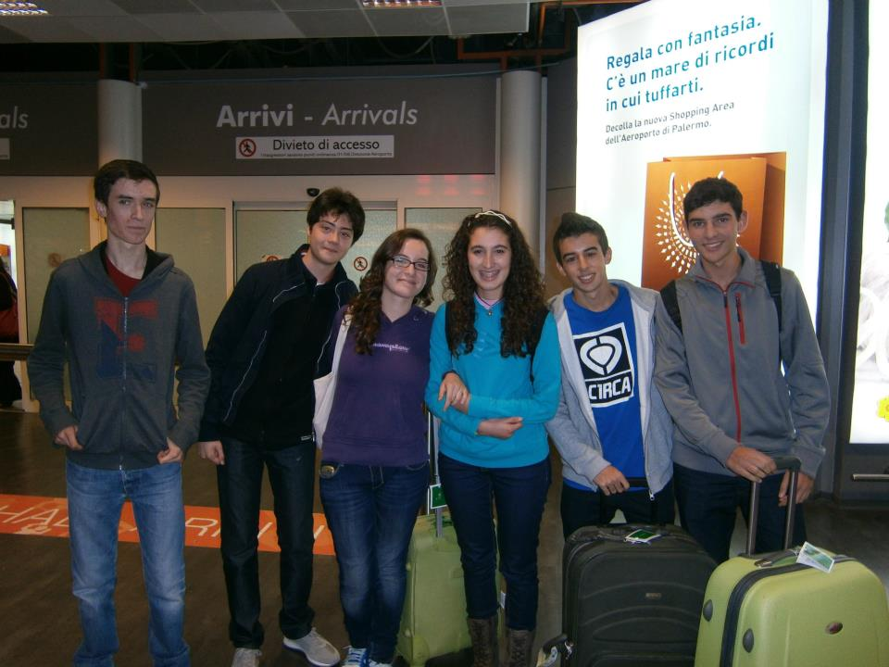

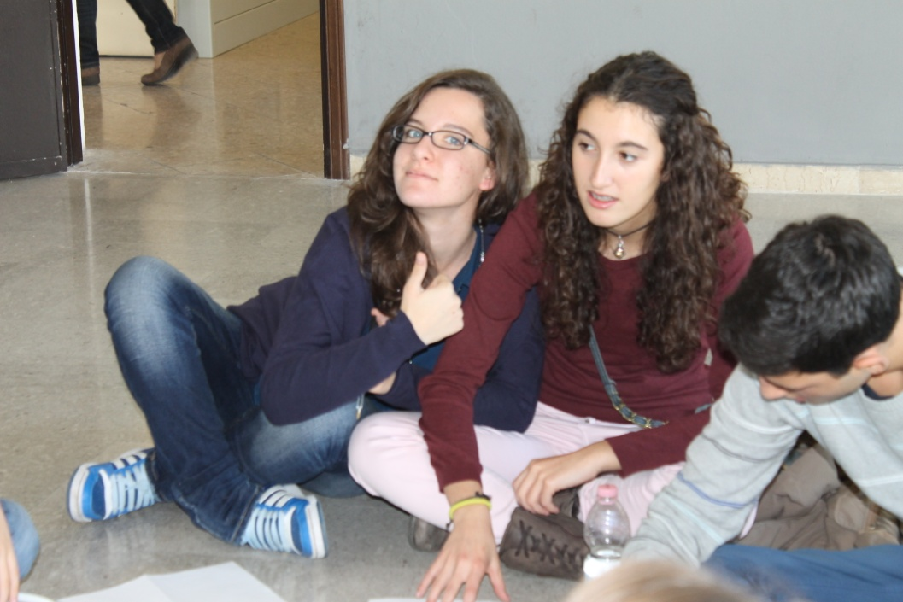
When she was arriving, I was very happy but also a bit nervous because I’ve been waiting her for a long time and I wanted to do all my best to make her feels like home.
We had a lot of fun together, we talked about our hobbies, and families and pets, and we compared our habits and our schools.
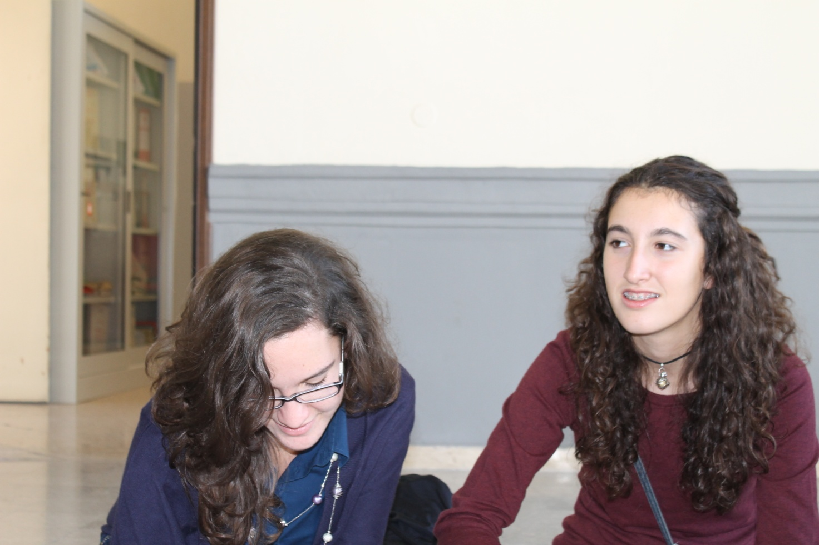
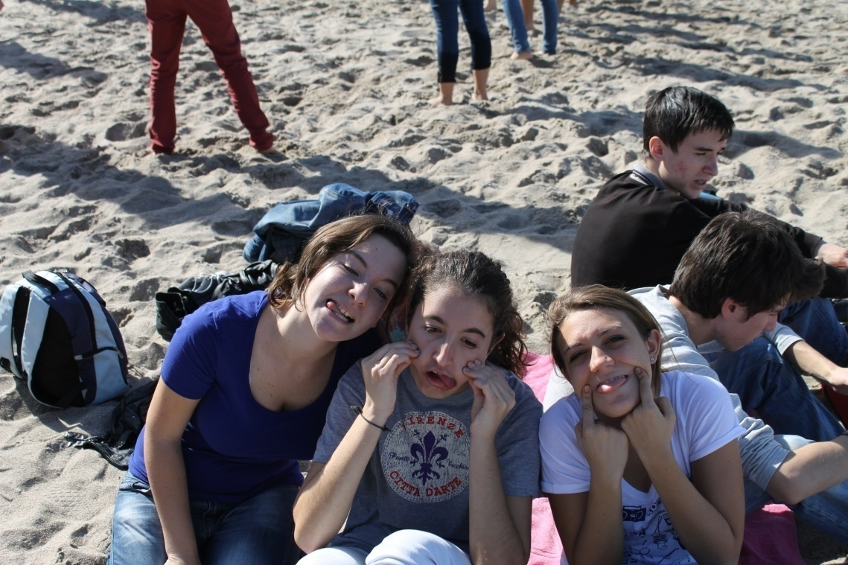
We meet with many people from different country and it was fantastic because we managed to understand each other and behave like friends of the same nationality.
In my opinion the most important message this experience left in ourselves is that, even if we had different languages and different countries, we were more similar and closer that we though.

During their stay we did a lot of things together:
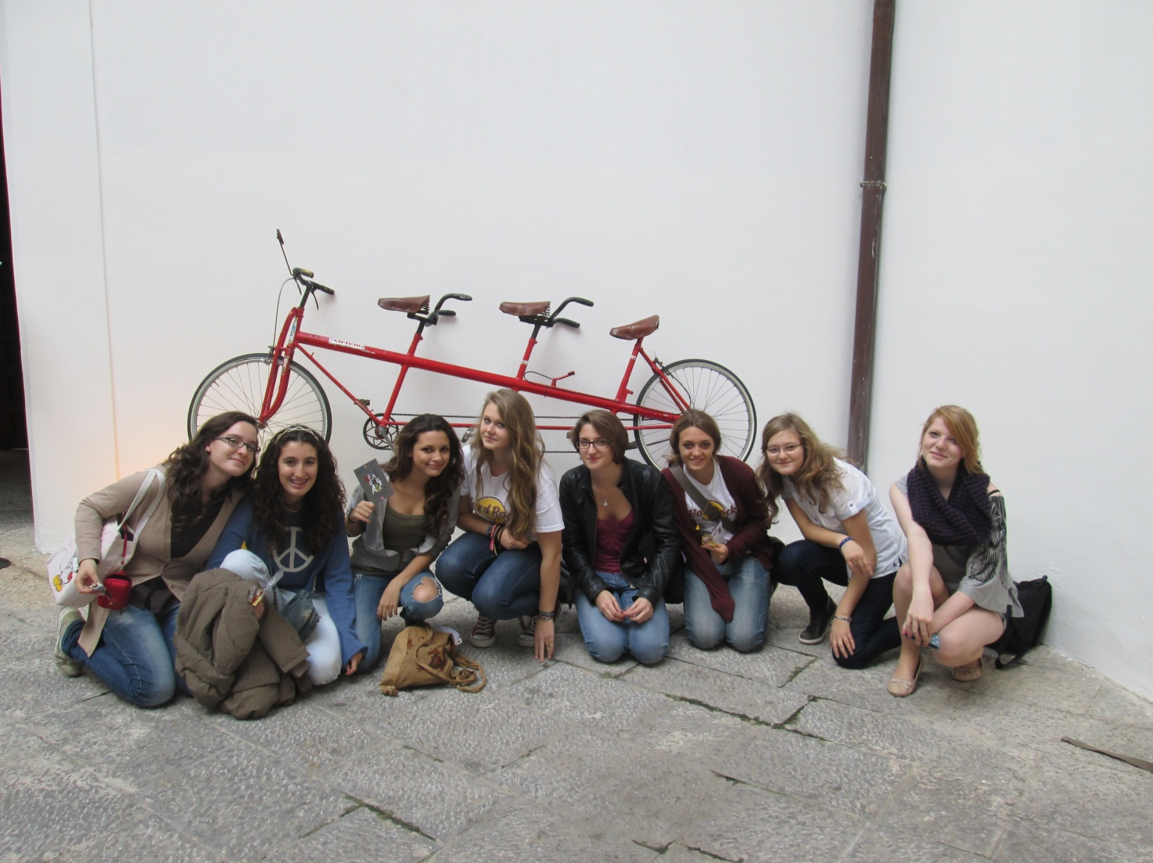
We visited a vintage pop-art museum

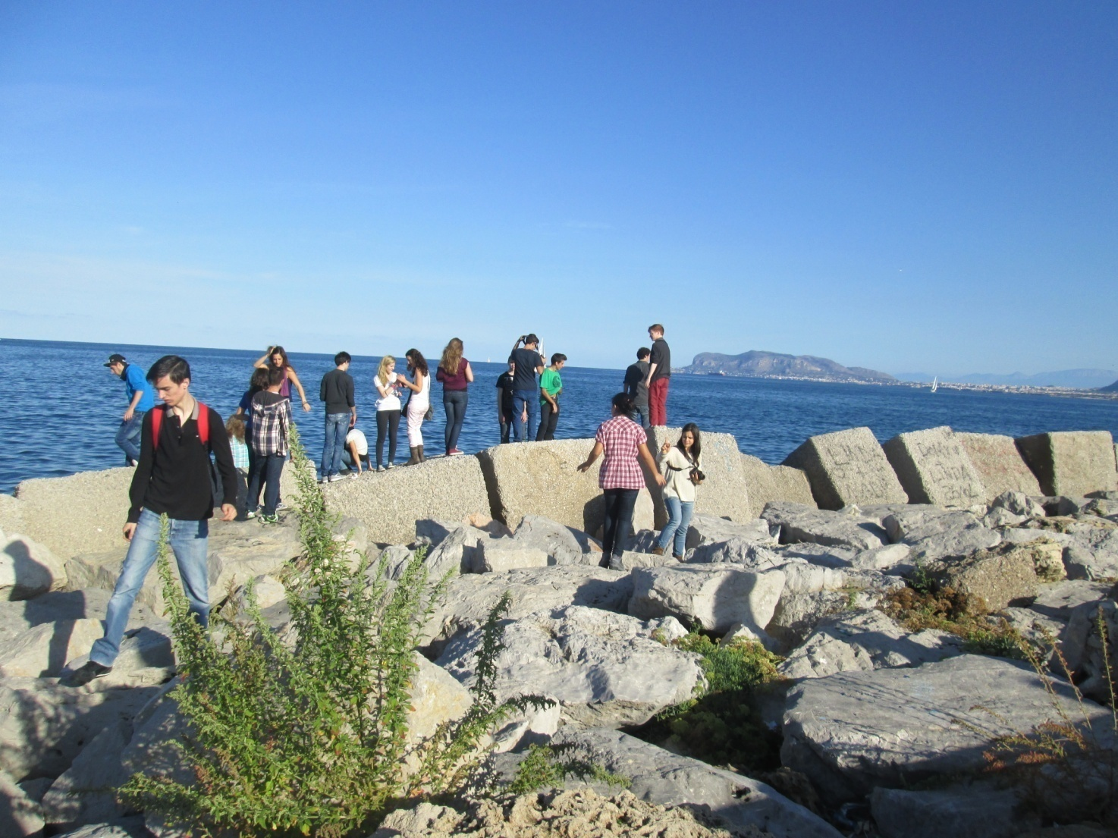
We went to the sea

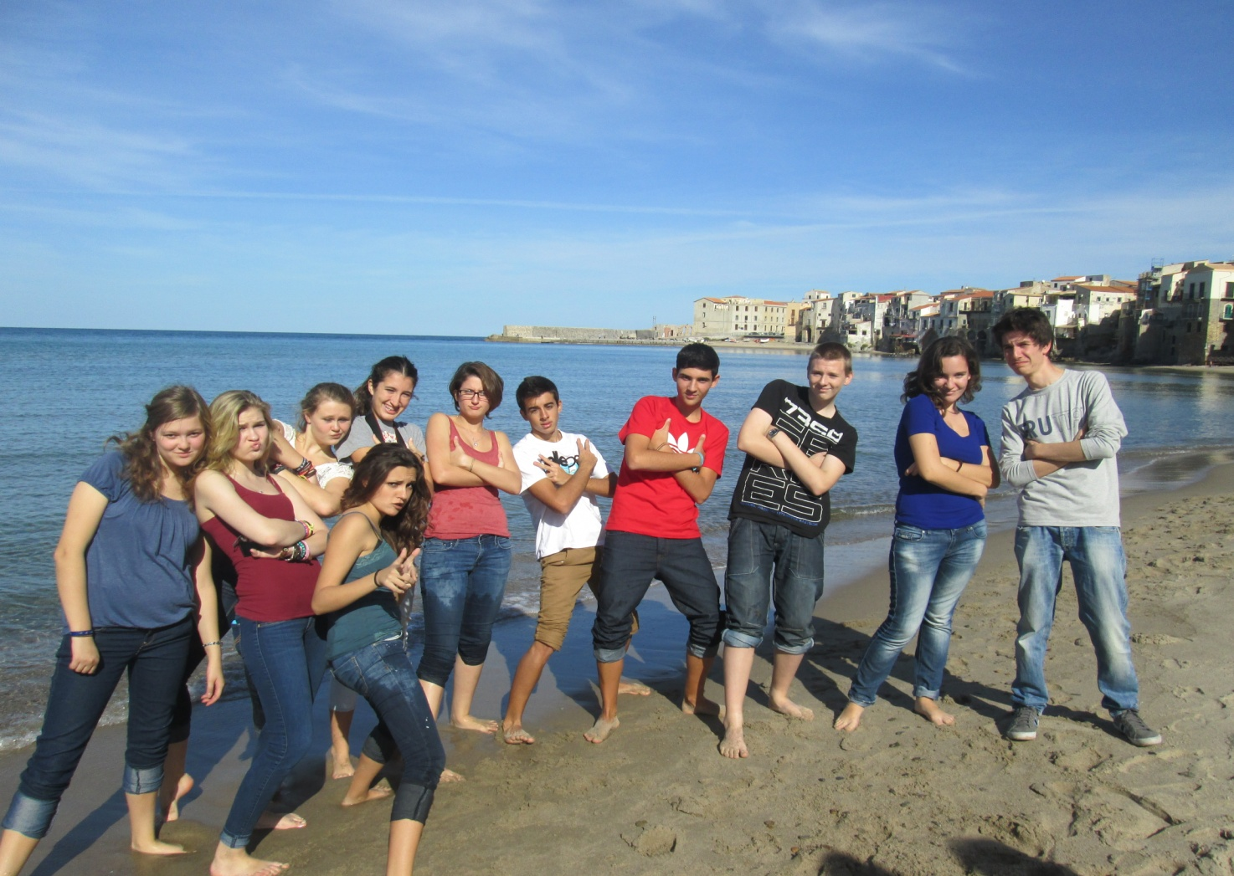
We went to Cefalù

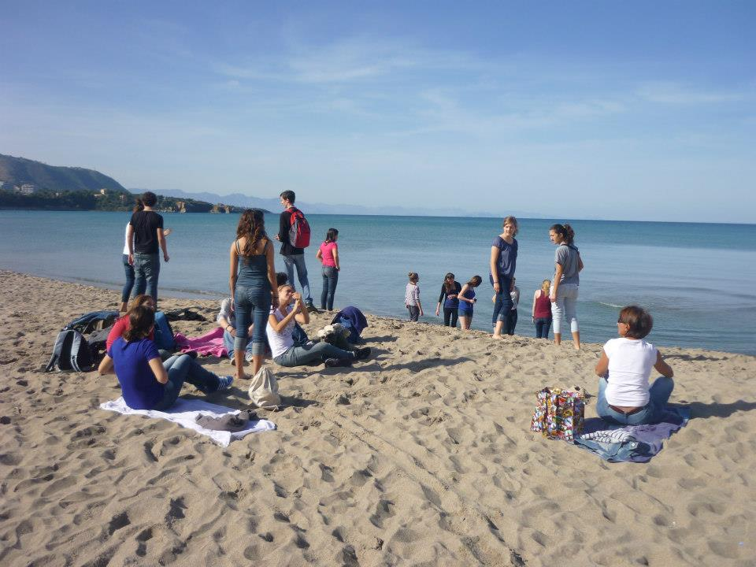
And finally we had a pizza…but unfortunately then arrived the worst moment: the time to say goodbye!

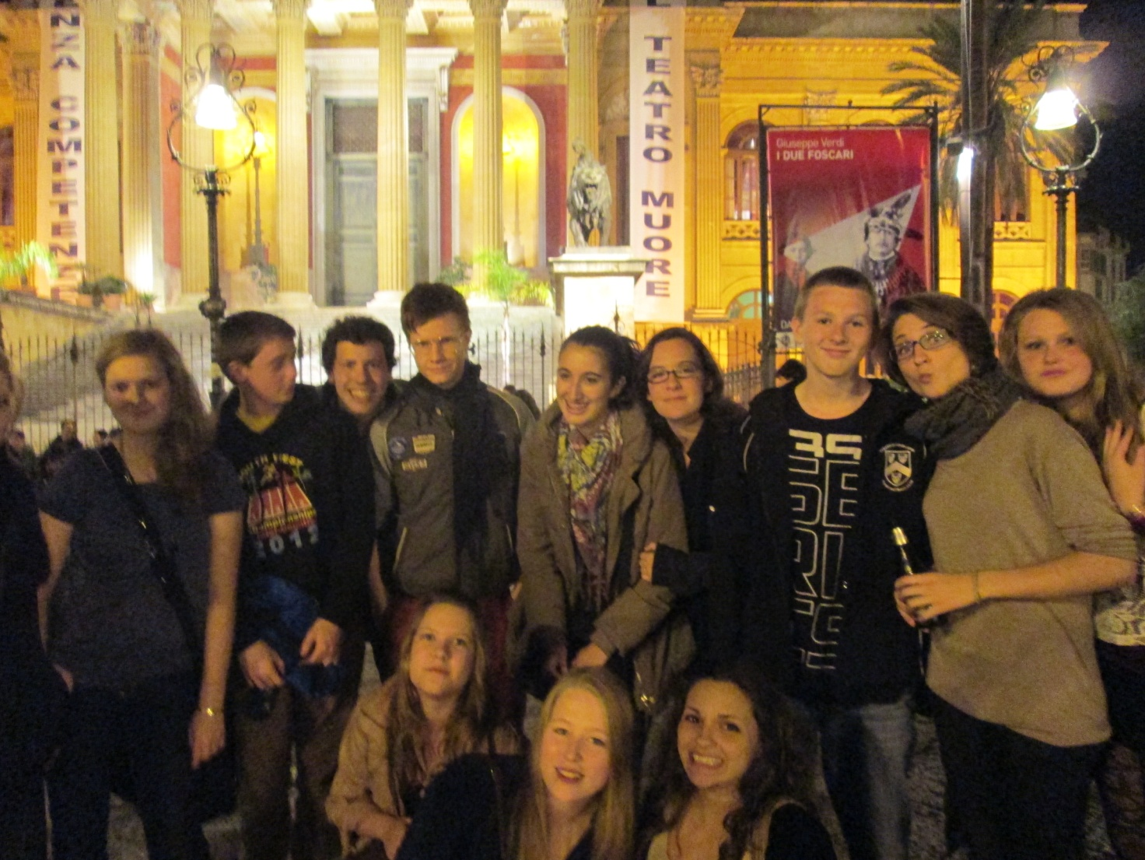

Now, thanks to Comenius, I have new friends all around Europe and I hope we will see us again because I miss all of them very very much.
See you in Malaga!

Arianna

