OUR TRIP TO MALAGA WITH COMENIUS

Hi! We are three Italian students, Arianna, Francesco and Giovanni, and we are happy to talk about our experience with Comenius.
Last November we hosted three Spanish students from Malaga: Livia, Miguel and Ricardo, so we were hosted from them last March.
We were so excited for this fantastic opportunity! We couldn’t bear the joy to have the chance to learn and have fun! We left from Palermo the 6th of March, we arrived in Malaga at 1 p.m. and our twins were waiting for us in the airport: it was very exciting to see them again after three months! Then we went to their school where the other guys was waiting to know us; they were extremely kind and welcoming since the first moment.

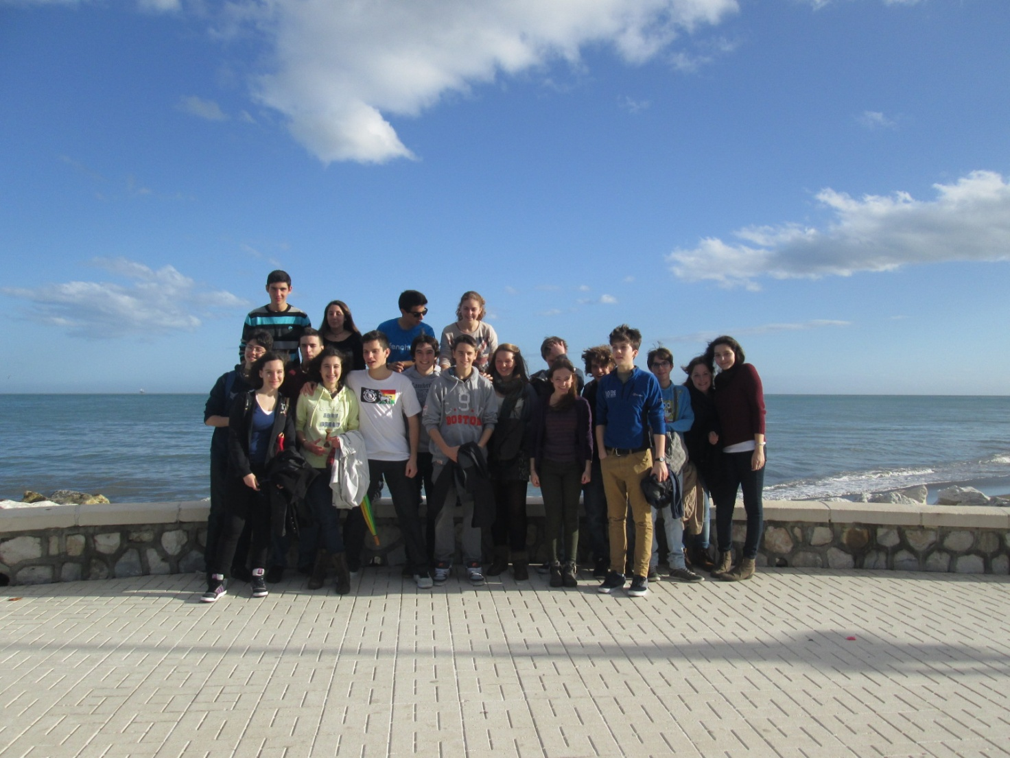

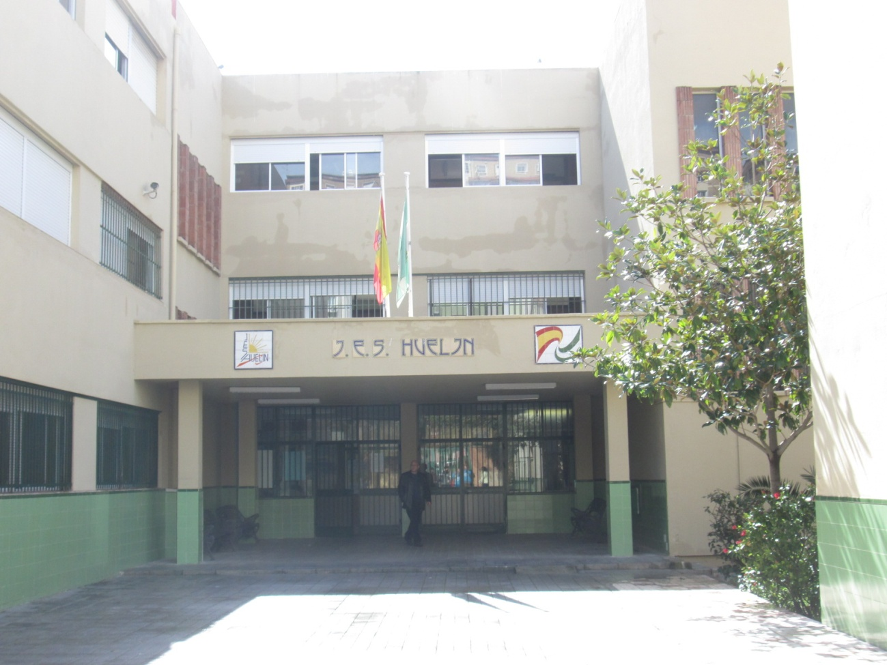

Their school was quite similar to ours, but it also had a huge courtyard with some trees and benches, and a theatre were we carried out our activities.
Our host families were very friendly and kind, they were always helpful and generous. Malaga was a very beautiful and nice city, but in those days the weather changed very quickly, so it was sometimes rainy and cloudy, and sometimes sunny and warm. We tasted different tipical dishes when we were at home with our families or when we went out with the other guys, like tortilla, paella or churros.
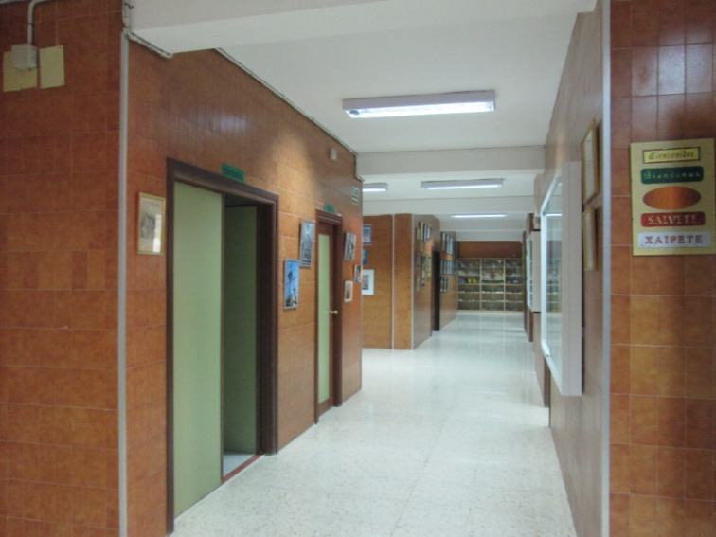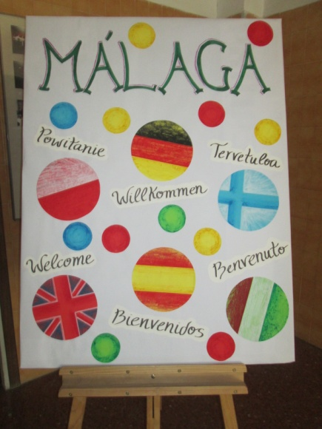
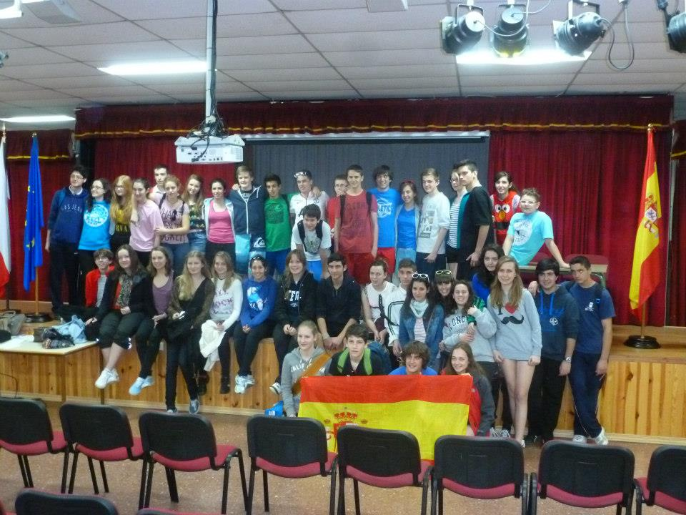
The day after our arrival, we went in the school theatre where we played a role-game organized by an economic teacher. The majority of the students were the employees and six of us were the employers; the aim of the employees was to get a job with the highest salary, the aim of the employers was to take on employees with the lowest salary and who remained unemployed had less points. So the teacher created the teams according to the results.
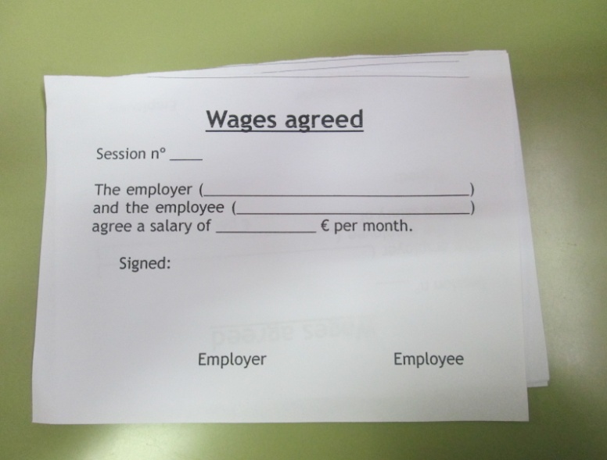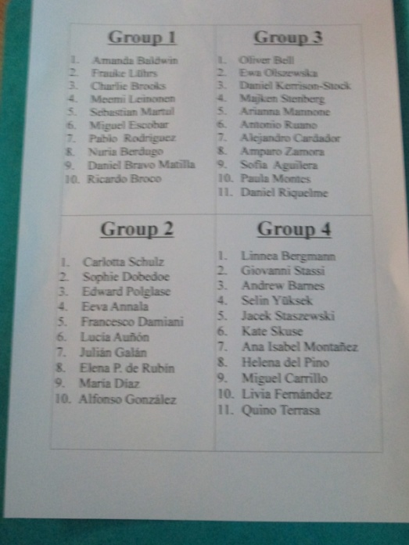
The same day we went to play on the beach; the activities were so funny: we played handkerchief game, volleyball, capture the flag, and someone also went swimming! When we left the beach we were very tired, but really happy.
On Friday we had an orienteering game in the forest; we had to find the road on pairs but we worked as a magnificent group all together and we really enjoyed ourselves. Participants are given a topographical map, usually a specially prepared orienteering map, which they use to find control points.
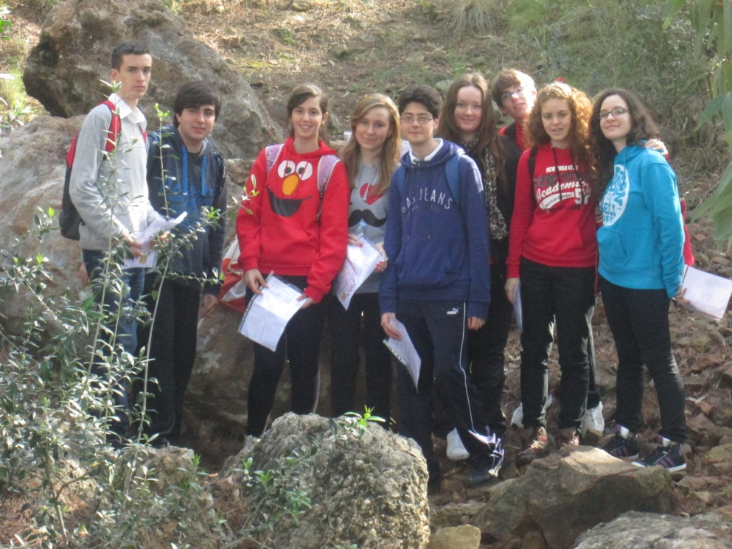
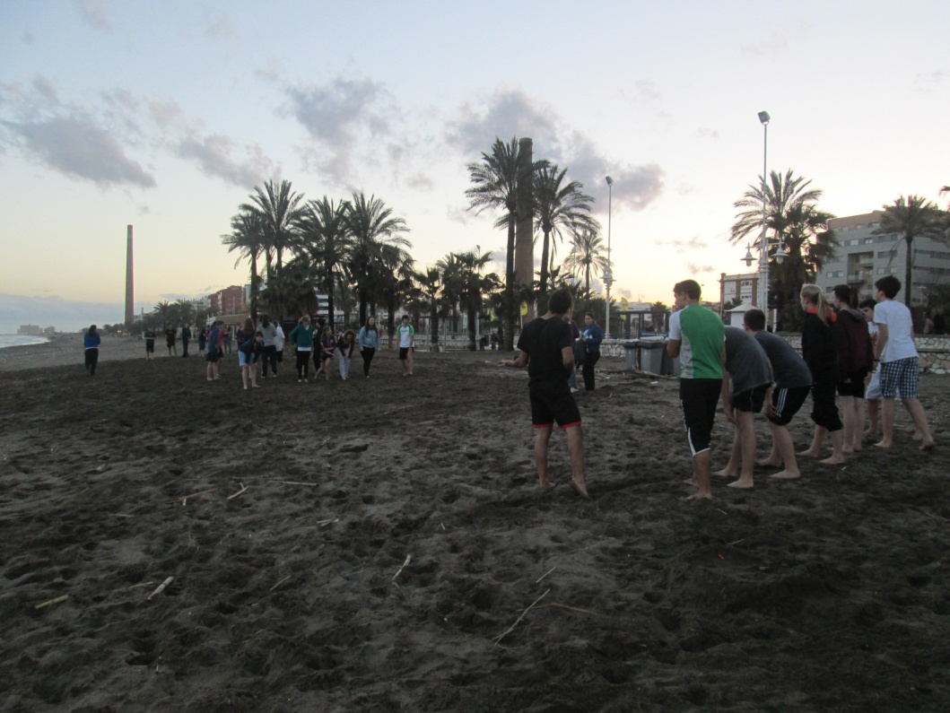

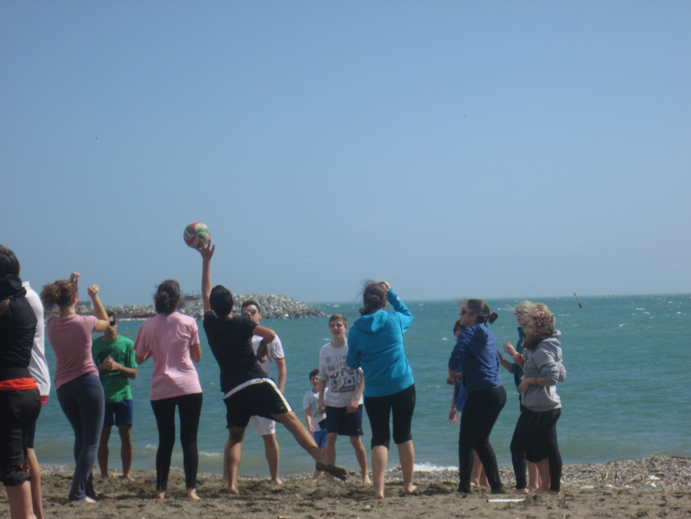

When we weren't busy with school's activities we went out with our twins all together. We had a walk along the beach and we went in a park. We also visited the centre, where you can spend hours and return to visit without ever getting bored; there’s so much to see that it’s impossible to even enumerate. In the center we saw the cathedral and we bought lots of souvenirs for our family! We also visited the Picasso’s Museum and then we had a walk along the promenade near the harbor. We also went to the Alcazaba, an Arab fortress pointing towards the sea.
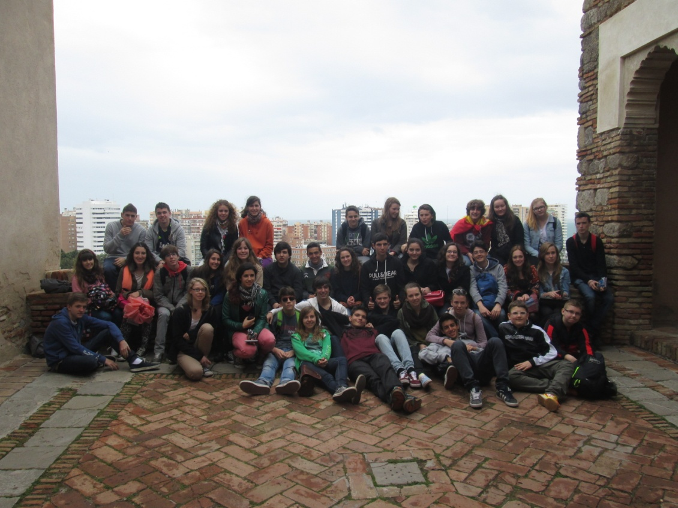
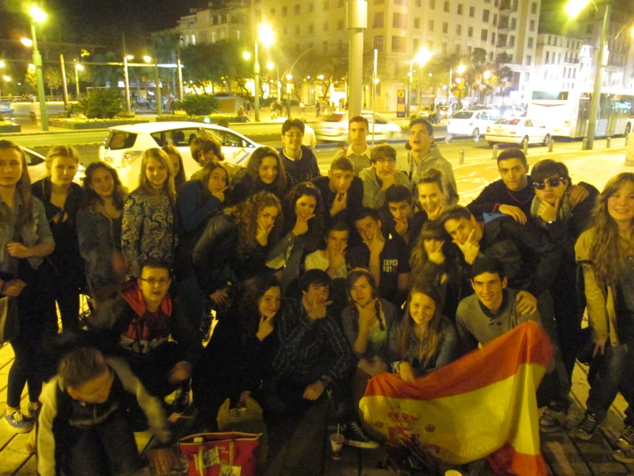

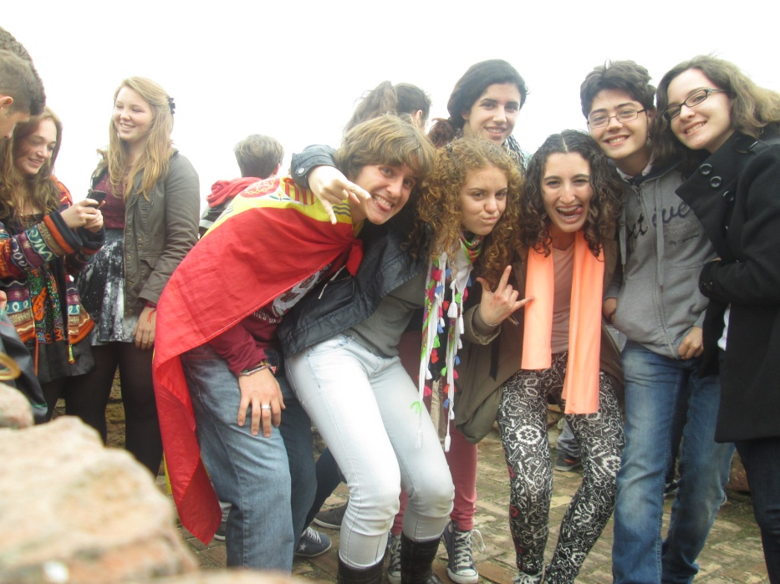

The Comenius project gave us the chance to experience new cultures and to meet new people that we wish to see again in the future. Our unforgettable experience is ended but the memory of these days and the amazing friends we met will always remain in our hearts.

